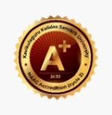
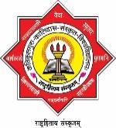
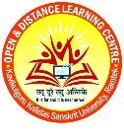

Kavikulaguru Kalidas Sanskrit University,
Ramtek, Dist. Nagpur (Maharashtra)
NAAC A+ grade
Open and Distance Learning Centre
(UGC Recognition Date.10/10/2022)

Admission Notification
- M.A. (Sanskrit)-2 Years (4 Semesters)
- M.A. (Yogashastra)-2 Years (4 Semesters) (15 Days practical in each semester will be Mandatory for Yogashastra programme)
- Diploma in Sanskrit Agam-1 Year (Yearly)
- Diploma in Early Child Care and Education-1 Year (Yearly)
- Diploma in Sanskrit Journalism and Mass Communication-1 Year (Yearly)
- Diploma in Yoga Application-1 Year (Yearly)
- Certificate Course in Spoken Sanskrit-6 Months
- Certificate Course in Sanskrit Writing-6 Months
- Certificate Course in Jyotish-6 Months
- Certificate Course in Vastu-6 Months
- Certificate Course in Bhagvadgeeta-6 Month
- Foundation Course in Spoken Sanskrit-1 Month
- Foundation Course in Yoga Deeksha-1 Month

- Curriculum Medium-Sanskrit, Marathi, Hindi & English.
- Admission Eligibility- As per programme.
- Admission Link
M.A (Sanskrit) and M.A (Yogashastra) Admission Link
https://forms.gle/hAGkqwdMfgdoC8fV8

Diploma and Certificate Programme Admission Link
https://forms.gle/dKrqQEup4dk3Aqbr5

-:Contact:-

Director, Open and Distance Learning Centre,
Kavikulaguru Kalidas Sanskrit University,
Mouda Road, Ramtek, Dist. Nagpur-441106
Website - https://kksanskrituni.digitaluniversity.ac
E-mail id – odl@kksu.org

Contact Number

Prof. Dr. Kalapini Agasti-8275394979 Dr. Sumit Kathale-9049863646

Asstt. Prof. Shivarda Malage-9607991664 Asstt. Prof. Renushree Bansod-9607991663

